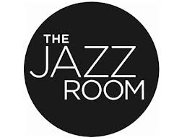

**59 King Street N., Waterloo, ON**

* **7:30 – 10:30**
* **Everyone Welcome**
* **$5 cover**

Jazz JAM

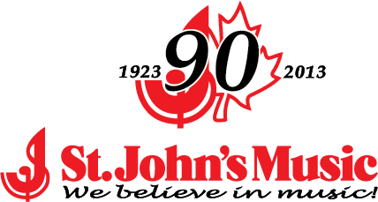

Thursday April 3rd

7:30pm